Lab Assignment AWS 1 (4.1, 4.2 Amazon AWS)

Chaudhary Hamdan

1905387

Date: 11-02-2022

Question: Amazon AWS Module 4 completion

Screenshots:

4.1

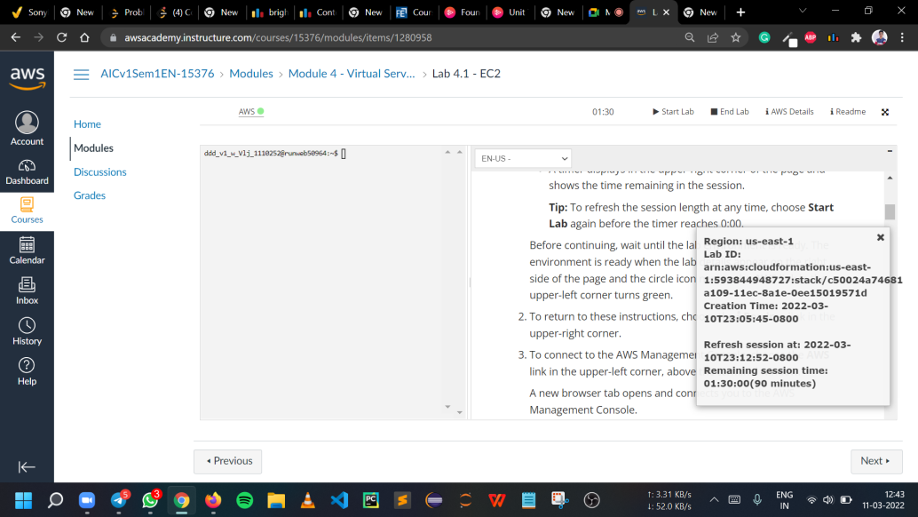

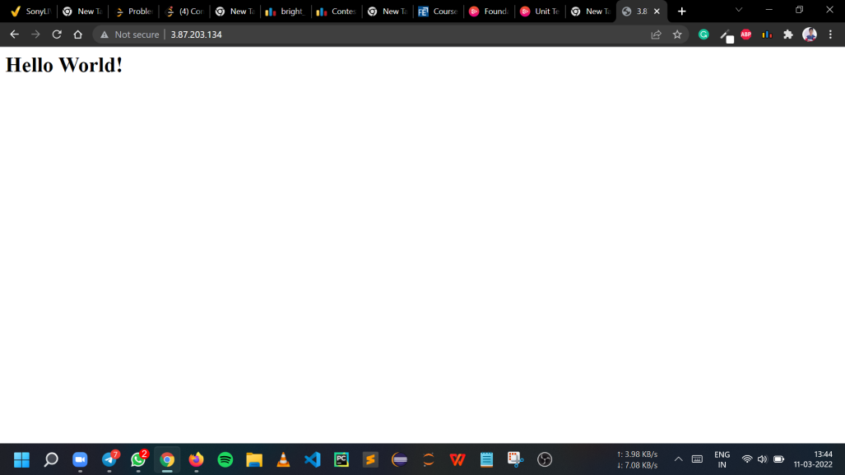

4.2

